Aim:

Write a Python program to print the calendar of a given month and year.

Program:

import calendar

year=int(input())

month=int(input())

if(year<10000 and year>999 and month<13 and month>0):

print(calendar.month(year,month))

else:

print("Invalid Input")

Link: <http://103.53.53.18/mod/vpl/forms/edit.php?id=229&userid=1680#>

Output:

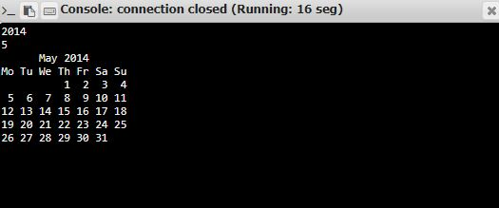

Result:

Thus the Python program is written and the calendar of the Month and year is Printed